Jefferson Bui

CMPSC 221

2020/02/05

Assignment 1

Question 1:

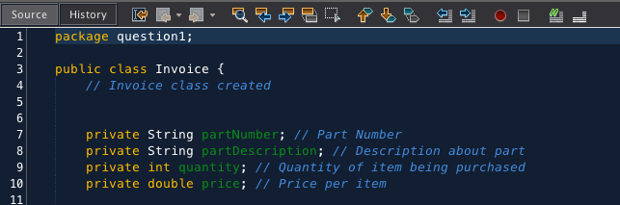\

Created Invoice class with the four instance variables required: part number(string), part description(string), quantity(int), and price(float). All instances are set to private.

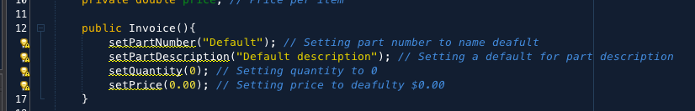

Created constructor to initialize the four instance variables.

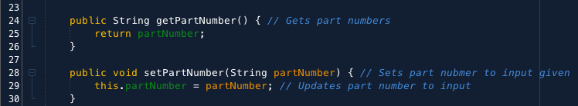

Setter and getter methods for part number.

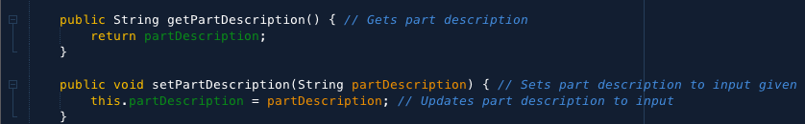

Setter and getter methods for part description.

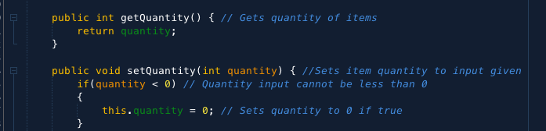

Setter and getter methods for quantity.

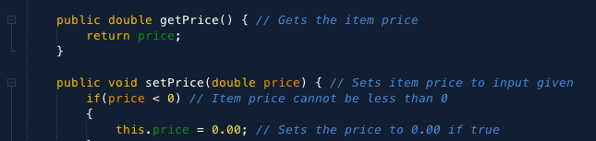

Setter and getter methods for price.



Created getInvoiceAmount method.

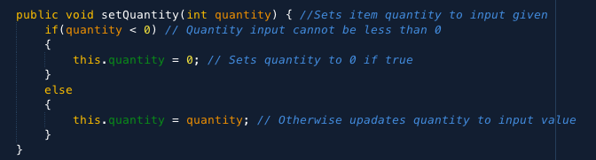

If quantity is not positive it is set to 0.

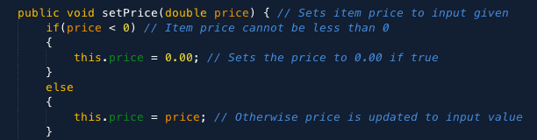

If item price is not positive than it is set to 0.00

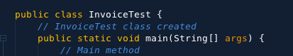

Created test app named InvoiceTest

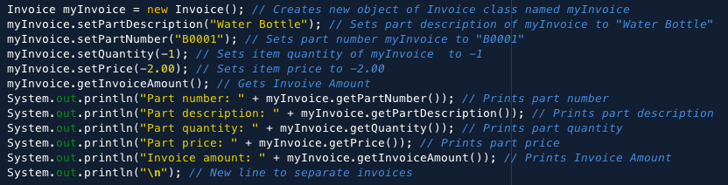

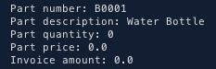

Created test case 1 with part description as “Water Bottle” with part number “B0001.” Entered negative values to test to make sure if values are not positive, then it returns 0 for quantity and 0.00 for price.

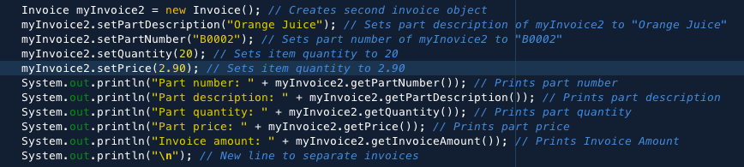

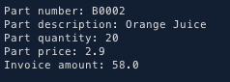

Created test case 2 with part description as “Orange Juice” with part number “B0002.” Entered in positive values to see if it returns the correct values.

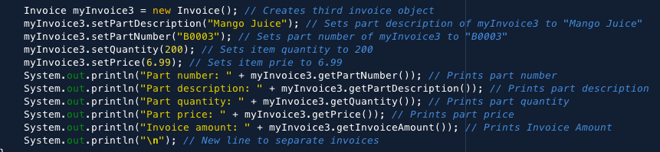

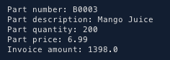

Created test case 3 with part description as “Mango Juice” with part number “B0003.” Entered in larger positive values to see if it returns the correct values.

Question 2:

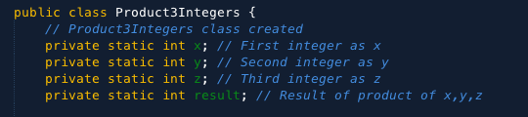

Created program that will calculate 3 integers. Named class as Product3Integers. Also created x, y, z, and result variables declared as int.

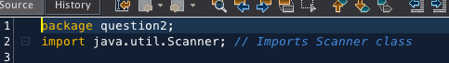



Imported Scanner class to create a scanner that read values from input.

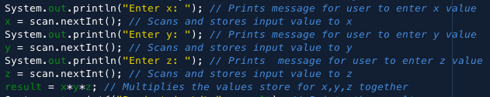

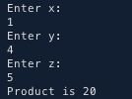

Prompts user to enter in values for x, y, z and stores it. Then it computes the product of the three and stores it as the result.



Then prints “Product is“ with the product it computed using System.out.printf().

Question 3:

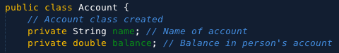

Created Account class with Name and Balance instance variables.



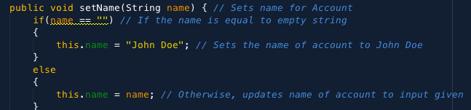

Setter and getter methods for name instance variable. SetName also checks for empty string. If empty it set Account name to John Doe. Otherwise, is set to the name that is inputed.



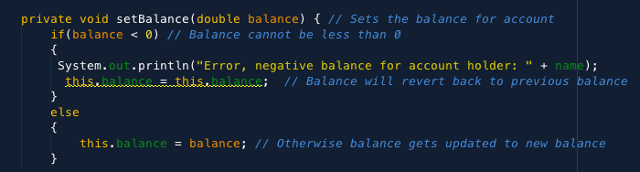

Setter and getter methods for balance instance variable. SetBalance is private and checks if balance is negative. If negative it shows pervious balance otherwise it updates.

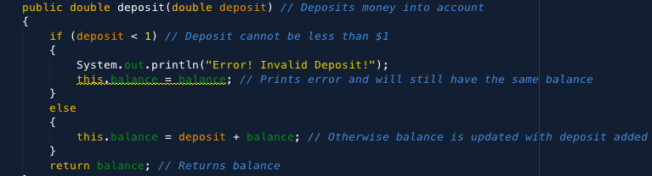

Created deposit method and it checks if deposit is less than 1. If less than 1 then is keeps previous balance. Otherwise, balance is updated with deposit added.

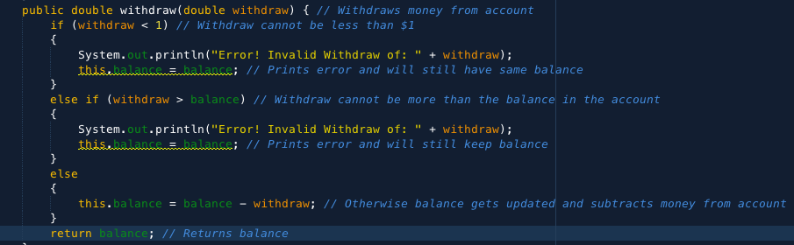

Created withdraw method and it checks if withdraw is less than 1. If less than1 then it keeps previous balance. Also, it checks if withdraw is greater than balance and won’t allow it. Otherwise money gets withdrawn from the account balance.

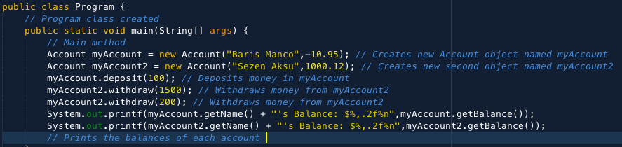



Ran given test case and creates accounts for the two people. The negative reflects in Baris’ account and gets error message. His account gets updated with the deposit. Sezen’s withdraw prints error because it exceeds his balance. His next withdraw it successful. Both balances get printed to the screen.

Question 4:

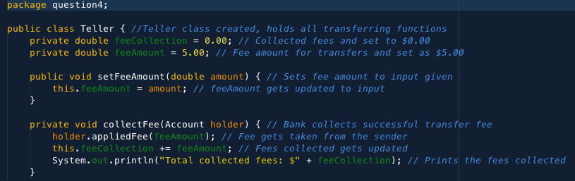

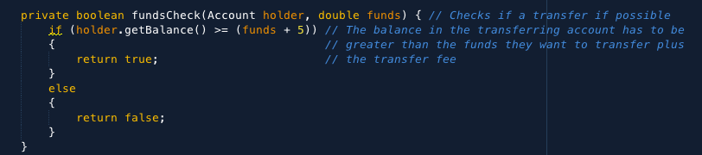

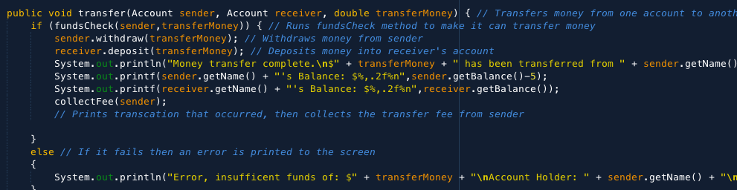

Created transfer method in a new class. It allows user to transfer money between two accounts. The fee collection method is also in this class. I created a new class because I felt that it would be easier to have all the functions of transferring money be handled in one class. I also remember doing the same when I coded in python. It’s cleaner in my eyes. Putting this in the main method is too restrictive for me with how I implemented this class. It didn’t feel right putting it in the account class either.

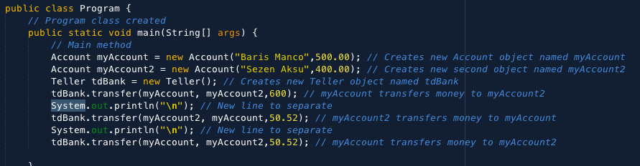



Ran test case given and created two accounts. I also created a new object of teller to perform all the transfer methods. Baris’ first transfer results in an error because he transfers more money than he has in his account.

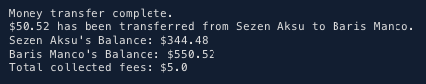

Second transfer from Sezen to Baris is completed. The money is moved from Sezen’s to Baris’. A $5 fee is also charged to Sezen’s account and collected.

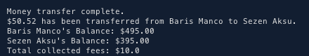

Last transfer from Baris to Sezen is completed. The money is moved from Baris’ to Sezen’s. The $5 fee is also collected from Baris’ account and the fee collected is updated.

Question 5:

1. I would prefer to initialize instance variables using Option 2. This way I don’t have to set the value for A every time as it will always be 10 or always set to a specific value. This especially for I don’t plan on constantly changing A’s value. In Option A you would have to constant set the value for A each time. Option 1 is preferred over Option 2 if you want users to be able to change the values of your variables and if they don’t need to use setters for their instances. Option 2 is preferred over Option 1 when you don’t want user to mess around with your variable values and preferred to access them only through setter and getter methods.
2. The purpose of a method parameter is that it acts as a variable inside a method passing that information to the method. The difference between a parameter and an argument is that a parameter is the data that the method takes in while an argument is the data that is passed to the method.

Cited source: https://www.w3schools.com/java/java_methods_param.asp

1. The difference between a local variable and instance variable is that a local variable can only be accessed within the method it is in while an instance variable can be access from anywhere within the class between different methods.
2. 